**Setting up Kubernetes Master Server**

Launch EC2 instance with Instance type ‘**t3.large’** & AZ should be **ap-soutj-1b** availability zone.

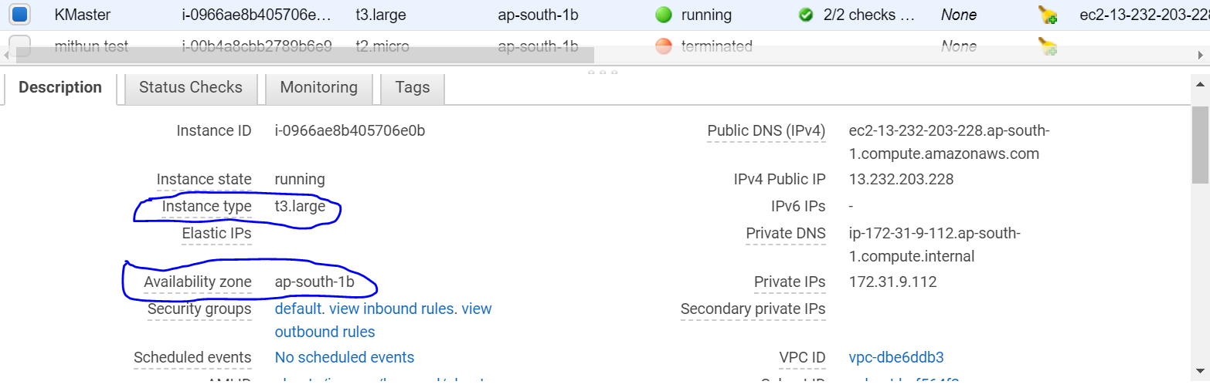

**Login as root.**

1 apt-get update

2 apt-get install docker.io -y || **To install Docker**

3 apt-get update

4 systemctl enable docker.service | **To enable docker services**

5 systemctl start docker.service | **To start doker services**

**Prerequisite for kube environment:**

6 apt-get update && apt-get install -y apt-transport-https -> To install https

7 curl -s https://packages.cloud.google.com/apt/doc/apt-key.gpg|apt-key add -

8 cat <<EOF >/etc/apt/sources.list.d/kubernetes.list  
deb http://apt.kubernetes.io/ kubernetes-xenial main  
EOF

9 apt-get update

10 apt-get install -y kubeadm kubectl kubelet

**11.**

**java –version 🡪 TO check Java version**

**apt install default-jre  
apt install default-jre  
apt install openjdk-11-jre-headless  
apt install openjdk-8-jre-headless  
apt install openjdk-9-jre-headless**

12.apt-get update

13.kubeadm init | **Only to run if you want to make your server as a master (Only master node)**

**(It can take some time)**

**14. To start using your cluster, you need to run the following as a regular user:**

mkdir -p $HOME/.kube  
cp -i /etc/kubernetes/admin.conf $HOME/.kube/config  
chown $(id -u):$(id -g) $HOME/.kube/config

15. **kubectl get nodes**

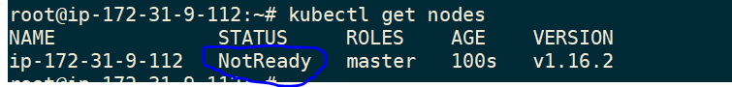

16.**kubectl get pods --all-namespaces** **|s All showing pending status because there is no pod network has been defined.**

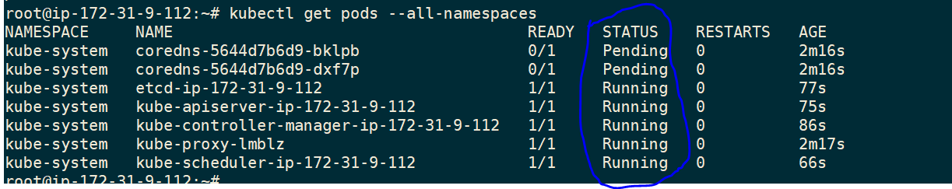

17.**kubectl apply -f https://docs.projectcalico.org/v3.10/manifests/calico.yaml**

18.**apt-get update**

19.**kubectl get pods --all-namespaces**

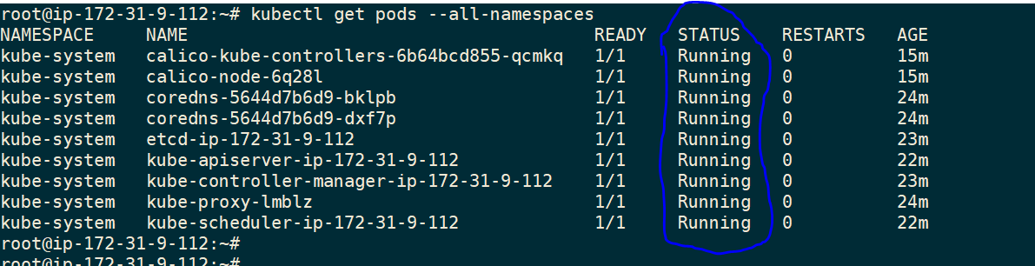

20.**kubectl cluster-info**



21.**kubectl get nodes**

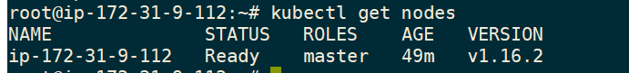

22.root@ip-172-31-9-112:~# **kubeadm token create --print-join-command**

kubeadm join 172.31.9.112:6443 --token jnhkbe.3835g4rixwiathz7 --discovery-token-ca-cert-hash sha256:2096c9cd3d82227a4da6139254df6e31dfd997ff0dfa503f6dba805b8e90579d

**Steps to setup Nodes:**

Launch EC2 instance with Instance type ‘**t3.large’** & AZ should be **ap-soutj-1b** availability zone.



**Login as root.**

1 apt-get update

2 apt-get install docker.io -y | **To install Docker**

3 apt-get update

4 systemctl enable docker.service | **To enable docker services**

5 systemctl start docker.service | **To start doker services**

**Prerequisite for kube environment:**

6 apt-get update && apt-get install -y apt-transport-https -> To install https

7 curl -s https://packages.cloud.google.com/apt/doc/apt-key.gpg|apt-key add -

8 cat <<EOF >/etc/apt/sources.list.d/kubernetes.list  
deb http://apt.kubernetes.io/ kubernetes-xenial main  
EOF

9. apt-get update

10. apt-get install -y kubeadm kubectl kubelet

11 apt-get update

**12.**

**java –version 🡪 TO check Java version**

sudo apt install default-jre  
apt install default-jre  
apt install openjdk-11-jre-headless  
apt install openjdk-8-jre-headless  
apt install openjdk-9-jre-headless

13. apt-get update

**Run the token as copied from K8server:**

kubeadm join 172.31.9.112:6443 --token jnhkbe.3835g4rixwiathz7 --discovery-token-ca-cert-hash sha256:2096c9cd3d82227a4da6139254df6e31dfd997ff0dfa503f6dba805b8e90579d

**How to make ssh connection between two EC2 instances:**

**Note: Please make sure you have both ip entries in their /etc/hosts file.**

**On Server end:**

ubuntu@ip-172-31-33-61:~$ ssh-keygen

Generating public/private rsa key pair.

Enter file in which to save the key (/home/ubuntu/.ssh/id_rsa):

cat .ssh/id_rsa.pub

**On Node:**

Go to authorized_keys file and paste output of **id_rsa.pub** which we have copied form servers **id_rsa.pub.**

ubuntu@ip-172-31-13-243:~$ cat .ssh/authorized_keys

<https://myopswork.com/how-to-install-kubernetes-k8-in-rhel-or-centos-in-just-7-steps-2b78331174a5>

<https://myopswork.com/how-to-install-kubernetes-k8-in-rhel-or-centos-in-just-7-steps-2b78331174a5>

[root@ip-172-31-42-23 ~]# history

1 pwd

2 clear

3 setenforce 0

4 sed -i --follow-symlinks 's/SELINUX=enforcing/SELINUX=disabled/g' /etc/sysconfig/selinux

5 firewall-cmd --permanent --add-port=6443/tcp

6 echo '1' > /proc/sys/net/bridge/bridge-nf-call-iptables

7 cat <<EOF > /etc/yum.repos.d/centos.repo

[centos]

name=CentOS-7

baseurl=http://ftp.heanet.ie/pub/centos/7/os/x86_64/

enabled=1

gpgcheck=1

gpgkey=http://ftp.heanet.ie/pub/centos/7/os/x86_64/RPM-GPG-KEY-CentOS-7

#additional packages that may be useful

[extras]

name=CentOS-$releasever - Extras

baseurl=http://ftp.heanet.ie/pub/centos/7/extras/x86_64/

enabled=1

gpgcheck=0

EOF

8 yum -y update

9 yum -y install docker

10 cat <<EOF > /etc/yum.repos.d/kubernetes.repo

[kubernetes]

name=Kubernetes

baseurl=https://packages.cloud.google.com/yum/repos/kubernetes-el7-x86_64

enabled=1

gpgcheck=1

repo_gpgcheck=1

gpgkey=https://packages.cloud.google.com/yum/doc/yum-key.gpg https://packages.cloud.google.com/yum/doc/rpm-package-key.gpg

EOF

11 setenforce 0

12 sed -i 's/^SELINUX=enforcing$/SELINUX=permissive/' /etc/selinux/config

13 sudo yum install -y yum-utils device-mapper-persistent-data lvm2

14 sudo yum-config-manager --enable rhel-7-server-extras-rpms

15 sudo -E yum-config-manager --add-repo "$DOCKERURL/rhel/docker-ee.repo"

16 sudo yum -y install docker-ee docker-ee-cli containerd.io

17 sudo yum install /path/to/package.rpm

18 sudo dnf repolist -v

19 dnf list docker-ce --showduplicates | sort -r

20 sudo dnf install https://download.docker.com/linux/centos/7/x86_64/stable/Packages/containerd.io-1.2.6-3.3.el7.x86_64.rpm

21 sudo dnf install docker-ce

22 sudo systemctl enable --now docker

23 sudo dnf install docker-ce

24 systemctl is-enabled docker

25 curl -L "https://github.com/docker/compose/releases/download/1.23.2/docker-compose-$(uname -s)-$(uname -m)" -o docker-compose

26 systemctl is-enabled docker

27 sudo dnf install docker-ce

28 top

29 $ sudo dnf config-manager --add-repo=https://download.docker.com/linux/centos/docker-ce.repo

30 sudo dnf config-manager --add-repo=https://download.docker.com/linux/centos/docker-ce.repo

31 sudo dnf repolist -v

32 dnf list docker-ce --showduplicates | sort -r

33 sudo dnf install docker-ce-3:18.09.1-3.el7

34 sudo dnf install --nobest docker-ce

35 sudo dnf install https://download.docker.com/linux/centos/7/x86_64/stable/Packages/containerd.io-1.2.6-3.3.el7.x86_64.rpm

36 sudo dnf install docker-ce

37 sudo systemctl disable firewalld

38 sudo systemctl enable --now docker

39 systemctl is-active docker

40 systemctl is-enabled docker

41 curl -L "https://github.com/docker/compose/releases/download/1.23.2/docker-compose-$(uname -s)-$(uname -m)" -o docker-compose

42 sudo mv docker-compose /usr/local/bin && sudo chmod +x /usr/local/bin/docker-compose

43 sudo dnf install python3-pip

44 pip3.6 install docker-compose --user

45 yum -y update

46 systemctl status docker

47 cat <<EOF > /etc/yum.repos.d/kubernetes.repo

[kubernetes]

name=Kubernetes

baseurl=https://packages.cloud.google.com/yum/repos/kubernetes-el7-x86_64

enabled=1

gpgcheck=1

repo_gpgcheck=1

gpgkey=https://packages.cloud.google.com/yum/doc/yum-key.gpg https://packages.cloud.google.com/yum/doc/rpm-package-key.gpg

EOF

48 setenforce 0

49 vi /etc/selinux/config

50 yum -y install kubelet kubeadm kubectl

51 systemctl start kubelet

52 systemctl enable kubelet

53 cat <<EOF > /etc/sysctl.d/k8s.conf

net.bridge.bridge-nf-call-ip6tables = 1

net.bridge.bridge-nf-call-iptables = 1

EOF

54 sysctl --system

55 echo 1 > /proc/sys/net/ipv4/ip_forward

56 kubeadm init --pod-network-cidr=10.244.0.0/16

57 kubectl get nodes

58 kubeadm init

ec2user@agv-master$ mkdir -p $HOME/.kube  
ec2user@agv-master$ sudo cp -i /etc/kubernetes/admin.conf $HOME/.kube/configec2user@agv-master$ sudo chown $(id -u):$(id -g) $HOME/.kube/config

59 pwd

60 history

[root@ip-172-31-42-23 ~]#

On Linux:

Download the latest release with the command:

curl -LO https://github.com/kubernetes/kops/releases/download/**$(**curl -s https://api.github.com/repos/kubernetes/kops/releases/latest | grep tag_name | cut -d '"' -f 4**)**/kops-linux-amd64

To download a specific version, replace the

**$(**curl -s https://api.github.com/repos/kubernetes/kops/releases/latest | grep tag_name | cut -d '"' -f 4**)**

portion of the command with the specific version.

For example, to download kops version v1.15.0 type:

curl -LO https://github.com/kubernetes/kops/releases/download/1.15.0/kops-linux-amd64

Make the kops binary executable

chmod +x kops-linux-amd64

Move the kops binary in to your PATH.

sudo mv kops-linux-amd64 /usr/local/bin/kops

6 apt-get update && apt-get install -y apt-transport-https -> To install https

7 curl -s https://packages.cloud.google.com/apt/doc/apt-key.gpg|apt-key add -

8 cat <<EOF >/etc/apt/sources.list.d/kubernetes.list  
deb http://apt.kubernetes.io/ kubernetes-xenial main  
EOF

9 apt-get update

10 apt-get install -y kubeadm kubectl kubelet